HyperText Transfer Protocol (HTTP)

* Hypertext
  + Embedded with hyperlinks
    - 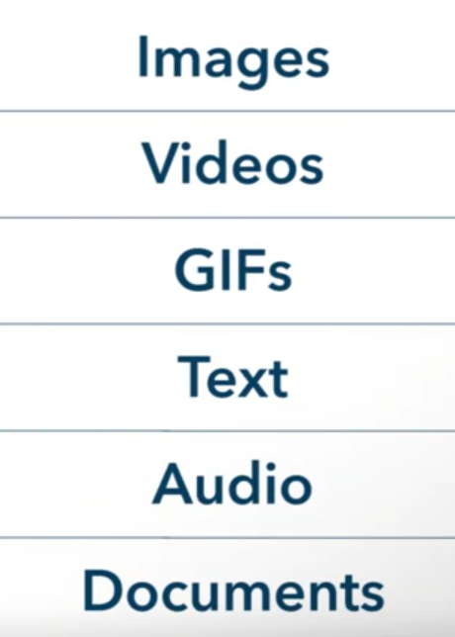
* A protocol that dictates how information is transferred across the internet

Universal Resource Identifiers (URIs)

* Address use to identify resources

Universal Resource Locators (URLs)

* A subset of URIs
* Locate resources
* Provide:
  + Protocol
  + Domain name or IP Address

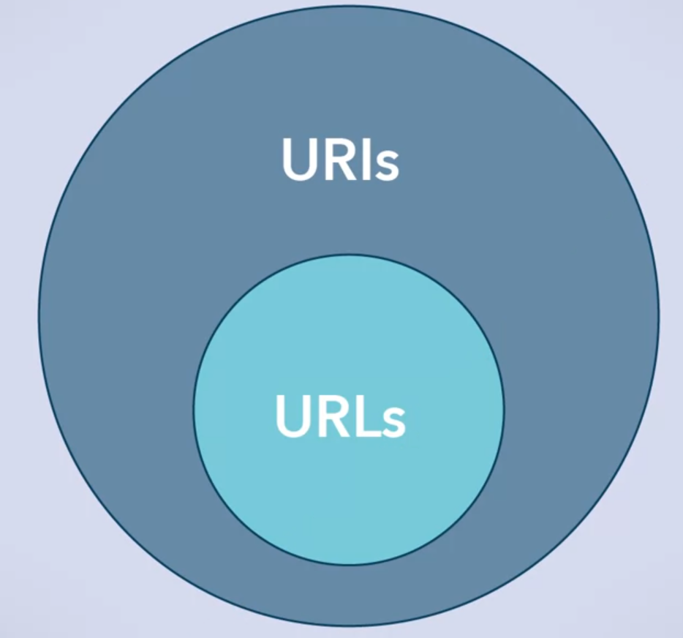

Example URIs

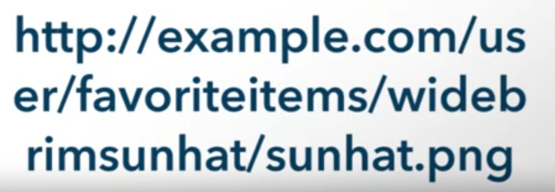

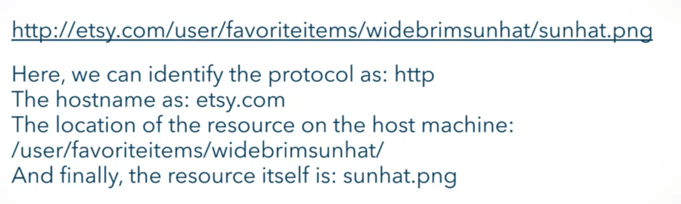

Domain Name System (DNS)

* Where the browser queries the IP Address of the domain

Transmission Control Protocol (TCP)

* Reliable
* Ordered
* Connection oriented communication

TCP Port 80

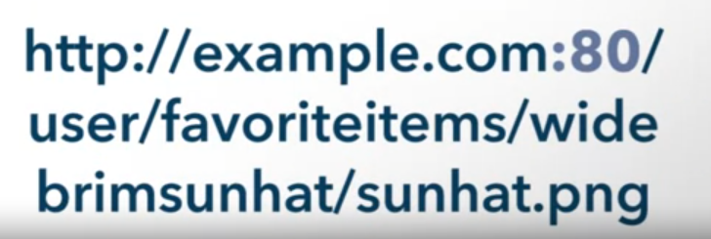

Client/Server Design

* This is what HTTP use

Client Request:

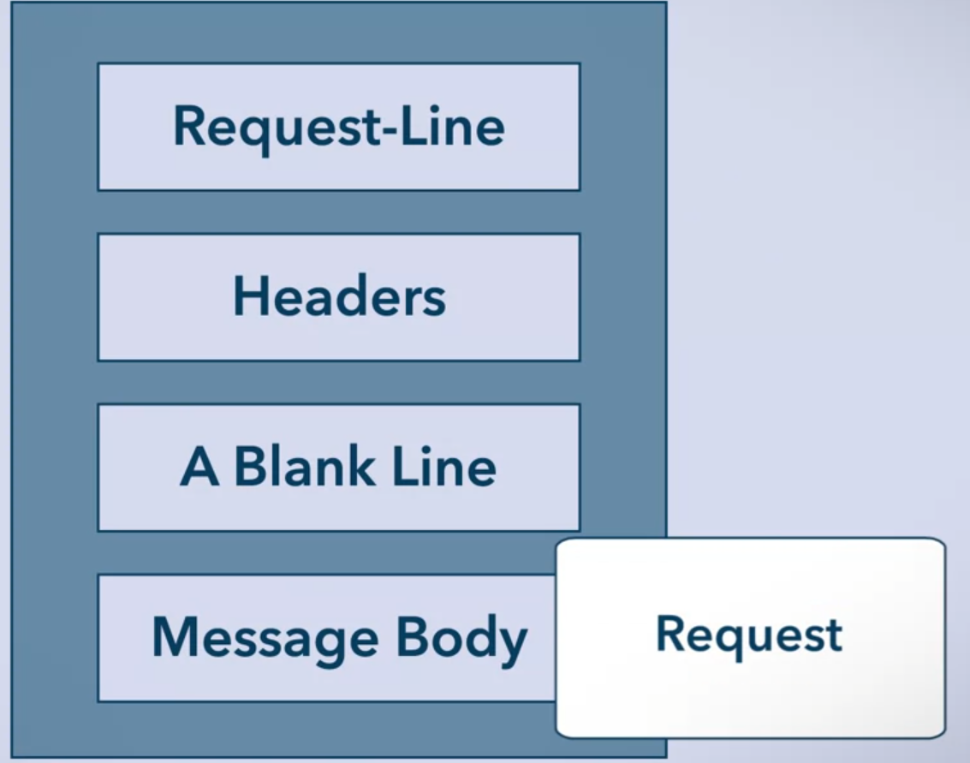

* Request-line
  + Method
  + URI
  + Protocol
* Headers
  + Must contain:
    - Host Header – contains domain name and IP Address
    - Accept Header – what kinds of content the client will accept as a response
  + if a message body is present
    - Content-Length Header – to indicate the size of the body in bytes
    - Content-Type Header – to indicate the type of the body
* Blank Line
  + If no message body is required
* Message Body
  + Maybe an HTML, JSON, etc.

Server Response:

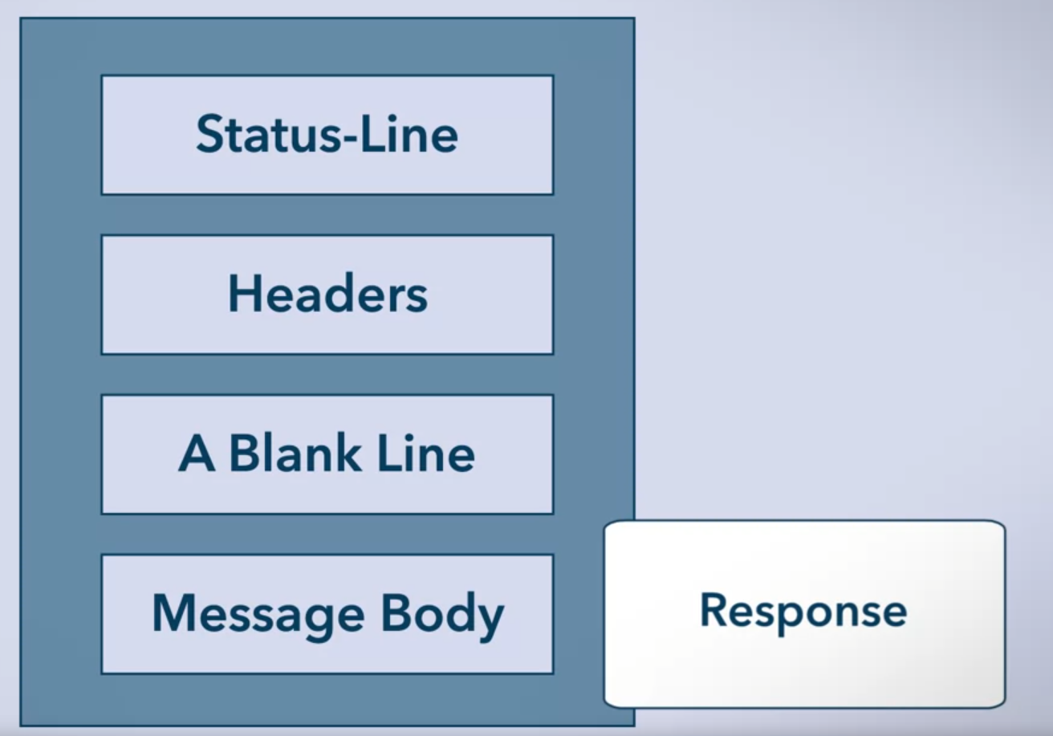

* Status-line
  + Protocol version
  + Status code
    - Eg. 200 OK
* Header
  + if a message body is present
    - Content-Length Header – to indicate the size of the body in bytes
    - Content-Type Header – to indicate the type of the body
* Blank Line
  + If no message body is required
* Message Body
  + Maybe an HTML, JSON, etc.

URL-Encoding

* ASCII
* Unsafe characters are replaced by % followed by its hexadecimal 2 digit encoding
  + Eg. Space: %20
    - 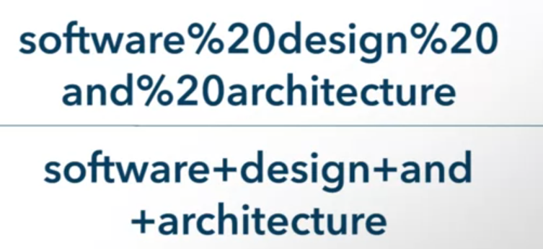
  + Query strings
    - 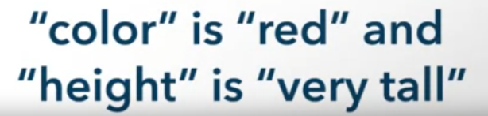
    - 

HTTP Request Methods

* Indicate to the server what it should do with the request
  + GET, POST, PUT …

Example of GET Request and Response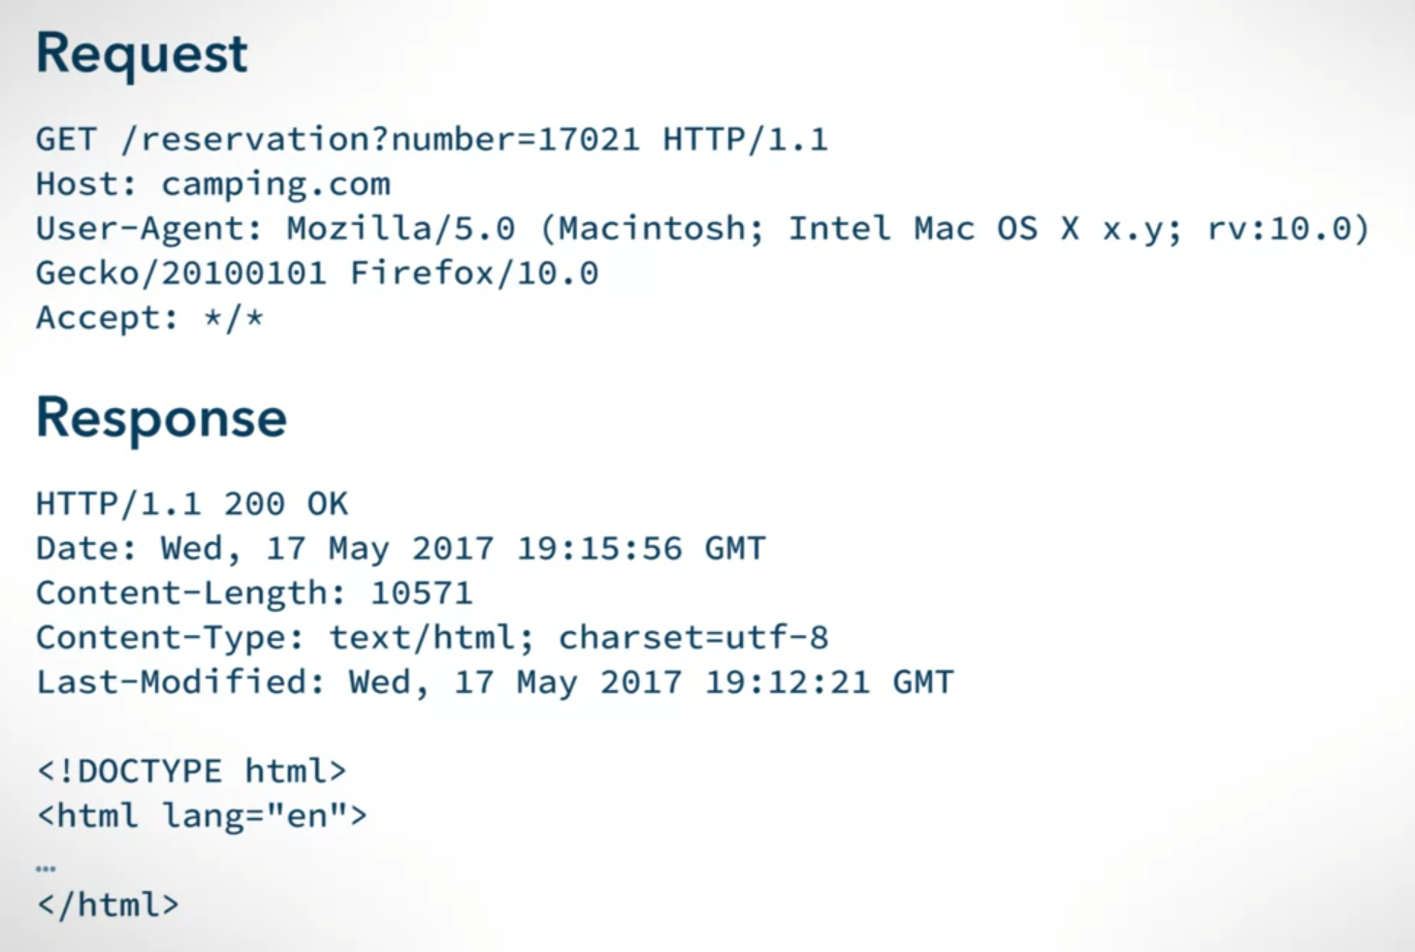

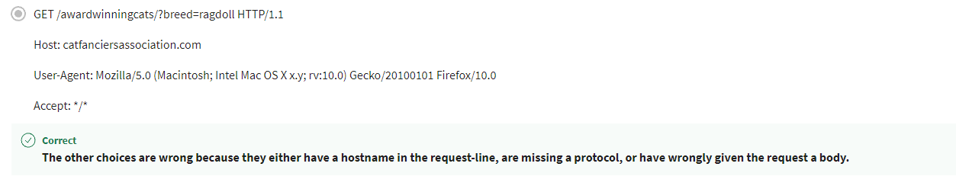

Example of POST Request and Response

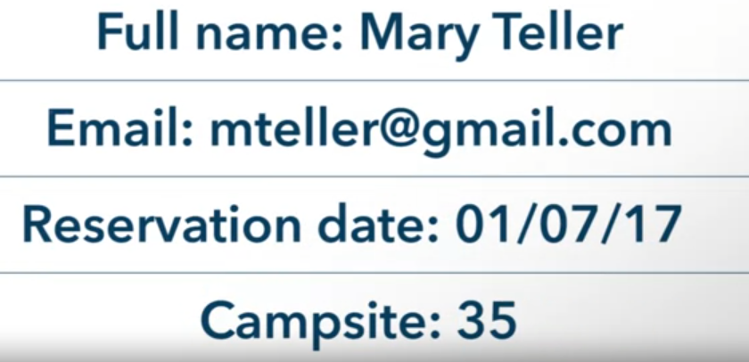

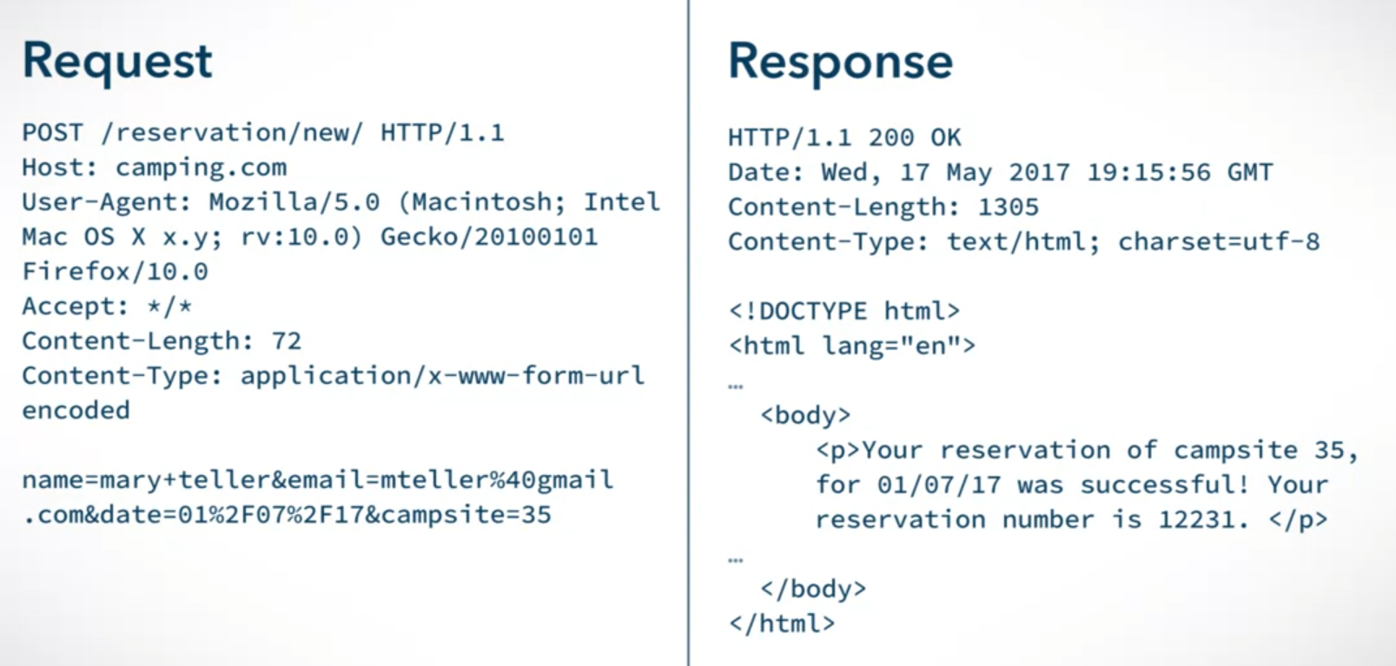

Example of PUT Request and Response

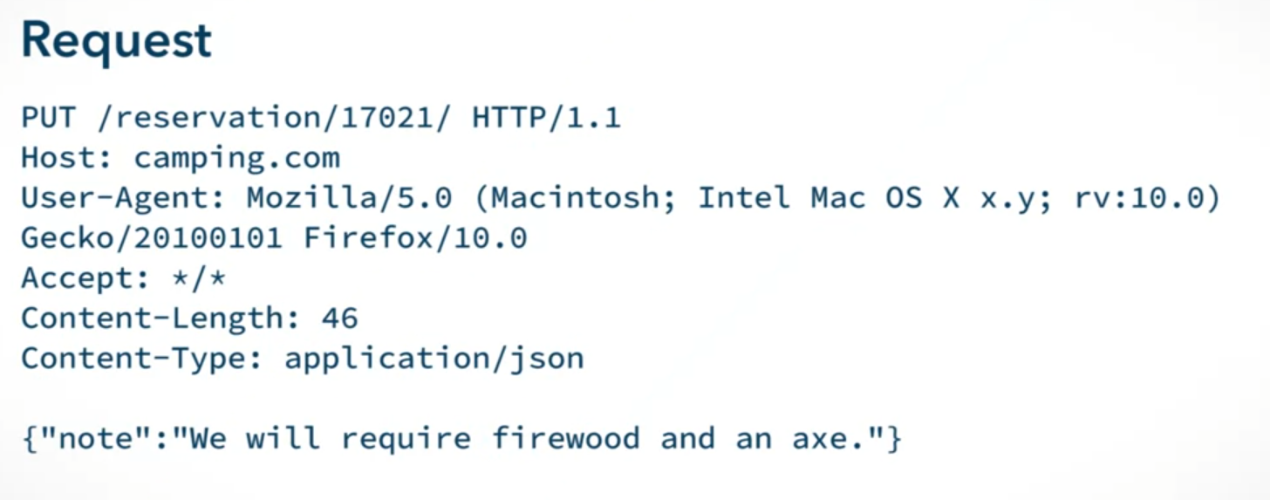

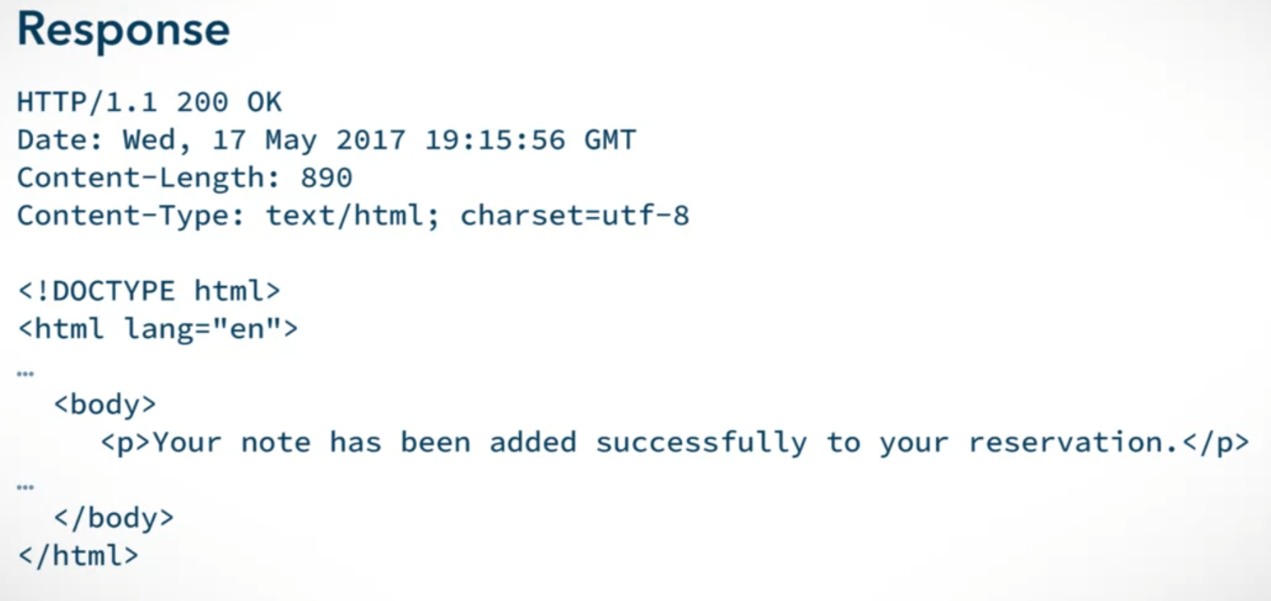

Statelessness in HTTP Requests

* Cookies store information about the user to prevent this statelessness
  + Useful for tracking purposes